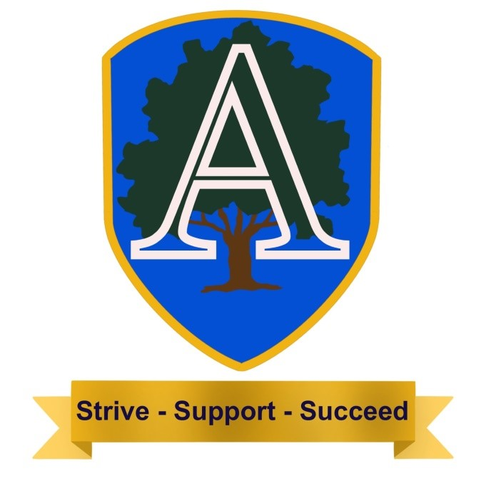
Subject Skills Progression: Science
EYFS/Key Stage 1
Skills Strand | EYFS |  | Year 1 | Year 2 | End of Key Stage Expectations
Plants | The World -ELG  Can I make observations of animals and plants and explain why some things occur, and talk about changes? |  | Year 1 NC:  Can I identify and name a variety of common wild and garden plants, including deciduous and evergreen trees?  Can I identify and describe the basic structure of a variety of common flowering plants, including trees? | Year 2 NC:  Can I observe and describe how seeds and bulbs grow into mature plants?  Can I find out and describe how plants need water, light and a suitable temperature to grow and stay healthy?
Animals including humans | The World -ELG  Can I make observations of  animals and plants and  explain why some things  occur, and talk about  changes? |  | Can I identify and name a  variety of common  animals including fish,  amphibians, reptiles, birds  and mammals identify  and name a variety of  common animals?  Can I identify and name a  variety of common  animals that are  carnivores, herbivores and  omnivores?  Can I describe and  compare the structure of  a variety of common  animals (fish, amphibians,  reptiles, birds and  mammals, including  pets)?  Can I identify, name, draw  and label the basic parts  of the human body and  say which part of the  body is associated with  each sense? | Year 2 NC:  Can I notice that animals,  including humans, have  offspring which grow into  adults?  Can I find out about and  describe the basic needs  of animals, including  humans, for survival  (water, food and air)?  Can I describe the  importance for humans of  exercise, eating the right  amounts of different types  of food, and hygiene?
Living things and their habitats | The World ELG  Children know about  similarities and differences  in relation to places,  objects, materials and living  things. |  |  | Year 2 NC:  Can I explore and  compare the differences  between things that are  living, dead and things  that’s have never been  alive?  Can I identify that most  living things live in habitats  to which they are suited  and describe how  different habitats provide  for the basic needs of  different kinds of animals  and plants and how they  depend on each other?  Can I identify and name a  variety of plants and  animals in their habitats,  including micro-habitats?  Can I describe how  animals obtain their food  from plants and other  animals, using the idea of  a simple food chain, and  identify and name  different sources of food?
Everyday Materials | The World ELG  Can I talk about similarities  and differences in relation  to places, objects, materials  and living things? |  | Year 1 NC:  Can I distinguish between  an object and the  material from which it is  made?  Can I identify and name a  variety of everyday  materials, including wood,  plastic, glass, metal,  water, and rock?  Can I describe the simple  physical properties of a  variety of everyday  materials?  Can I compare and group  together a variety of  everyday materials on the  basis of their simple  physical properties? | Year 2 NC:  Can I identify and  compare the suitability of  a variety of everyday  materials, including wood,  metal, plastic, glass, brick,  rock, paper and  cardboard for particular  uses?  Can I find out how the  shapes of solid objects  made from some  materials can be  changed by squashing,  bending, twisting and  stretching?
Seasonal Changes | The World 40-60m  Can I look closely at  similarities, differences,  patterns and change?  The World ELG  Can I talk about the  features of my own  immediate  environment and how  environments might vary  from one another? |  | Year 1 NC:  Can I observe changes  across the four seasons?  Can I observe and describe  weather associated with  the seasons and how day  length varies?
Working Scientifically |  | Year 1 & 2 NC:  Can I ask simple questions and recognising that they can be answered in different  ways?  Can I observe closely, using simple equipment?  Can I perform simple tests?  Can I identify and classify using my observations and ideas to suggest answers to  questions?  Can I gather and record data to help in answering questions?

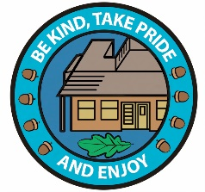
Subject Skills Progression: Science
Key Stage 2
Skills Strand | Year 3 | Year 4 | Year 5 | Year 6 | End of Key Stage Expectations
Plants | Year 3 NC:  Can I identify and  describe the functions  of different parts of  flowering plants: roots,  stem/trunk, leaves and  flowers?  Can I explore the  requirements of plants  for life and growth (air,  light, water, nutrients  from soil, and room to  grow) and how they  vary from plant to  plant?  Can I investigate the  way in which water is  transported within  plants?  Can I explore the part  that flowers play in the  life cycle of flowering  plants, including  pollination, seed  formation and seed  dispersal?
Animals, including humans | Year 3 NC:  Can I identify that  animals, including  humans, need the right  types and amount of  nutrition, and that they  cannot make their own  food; they get nutrition  from what they eat?  Can I identify that  humans and some  other animals have  skeletons and muscles  for support, protection  and movement? | Year 4 NC:  Can I describe the simple  functions of the basic parts of  the digestive system in  humans?  Can I identify the different  types of teeth in humans and  their simple functions?  Can I construct and interpret  a variety of food chains,  identifying producers,  predators and prey? | Year 5 NC:  Can I describe the changes  as humans develop to old  age? | Year 6 NC:  Can I identify and name the main  parts of the human circulatory  system, and describe the  functions of the heart, blood  vessels and blood?  Can I recognise the impact of  diet, exercise, drugs and lifestyle  on the way their bodies  function?  Can I describe the ways in which  nutrients and water are  transported within animals,  including humans?
Living Things and their Habitats |  | Year 4 NC:  Can I recognise that living  things can be grouped in a  variety of ways?  Can I explore and use  classification keys to help  group, identify and name a  variety of living things in my  local and wider environment?  Can I recognise that  environments can change  and that this can sometimes  pose dangers to living things? | Year 5 NC:  Can I describe the  differences in the life cycles  of a mammal, an amphibian,  an insect and a bird?  Can I describe the life  process of reproduction in  some plants and animals? | Year 6 NC:  Can I describe how living things  are classified into broad groups  according to common  observable characteristics and  based on similarities and  differences, including microorganisms,  plants and animals?  Can I give reasons for classifying  plants and animals based on  specific characteristics?
Rocks | Year 3 NC:  Can I compare and  group together  different kinds of rocks  on the basis of their  appearance  and simple physical  properties?  Can I describe in simple  terms how fossils are  formed when things  that have lived are  trapped within rock?  Can I recognise that  soils are made from  rocks and organic  matter?
Light | Year 3 NC:  Can I recognise that I  need light in order to  see things and that  dark is the absence of  Light?  Can I notice that light is  reflected from  surfaces?  Can I recognise that  light from the sun can  be dangerous and that  there are ways to  protect my eyes?  Can I recognise that  shadows are formed  when the light from a  light source is blocked  by a solid object?  Can I find patterns in  the way that the size of  shadows change? |  |  | Year 6 NC:  Can I recognise that light appears  to travel in straight lines?  Can I use the idea that light  travels in straight lines to explain  that objects are seen because  they give out or reflect light into  the eye?  Can I explain that we see things  because light travels from light  sources to our eyes or from light  sources to objects and then to our  eyes?  Can I use the idea that light  travels in straight lines to explain  why shadows have the same  shape as the objects that cast  them?
Forces and Magnets | Year 3 NC:  Can I compare how  things move on  different surfaces?  Can I notice that some  forces need contact  between two objects,  but magnetic forces  can act at a distance?  Can I observe how  magnets attract or  repel each other and  attract some materials  and not others?  Can I compare and  group together a  variety of everyday  materials on the basis  of whether they are  attracted to a magnet,  and identify some  magnetic materials?  Can I describe  magnets as having two  poles?  Can I predict whether  two magnets will  attract or repel each  other, depending on  which poles are  facing? |  | Year 5 NC:  Can I explain that  unsupported objects fall  towards the Earth because of  the force of gravity acting  between the Earth and the  falling object?  Can I identify the effects of  air resistance, water  resistance and friction, that  act between moving  surfaces?  Can I recognise that some  mechanisms, including levers,  pulleys and gears, allow a  smaller force to have a  greater effect?
States of Matter |  | Year 4 NC:  Can I compare and group  materials together, according  to whether they are solids,  liquids or gases?  Can I observe that some  materials change state when  they are heated or cooled,  and measure or research the  temperature at which this  happens in degrees Celsius  (°C)?  Can I identify the part played  by evaporation and  condensation in the water  cycle and associate the rate  of evaporation with  temperature?
Sound |  | Year 4 NC:  Can I identify how sounds are  made, associating some of  them with something  vibrating?  Can I recognise that vibrations  from sounds travel through a  medium to the ear?  Can I find patterns between  the pitch of a sound and  features of the object that  produced it?  Can I find patterns between  the volume of a sound and  the strength of the vibrations  that produced it?  Can I recognise that sounds  get fainter as the distance  from the sound source  increases?
Electricity |  | Year 4 NC:  Can I identify common  appliances that run on  electricity?  Can I construct a simple series  electrical circuit, identifying  and naming its basic parts,  including cells, wires, bulbs,  switches and buzzers?  Can I identify whether or not a  lamp will light in a simple series  circuit, based on whether or  not the lamp is part of a  complete loop with a battery?  Can I recognise that a switch  opens and closes a circuit and  associate this with whether or  not a lamp lights in a simple  series circuit?  Can I recognise some  common conductors and  insulators, and associate  metals with being  good conductors? |  | Year 6 NC:  Can I associate the brightness of  a lamp or the volume of a buzzer  with the number and voltage of  cells used in the circuit?  Can I compare and give reasons  for variations in how components  function, including the brightness  of bulbs, the loudness of buzzers  and the on/off position of  switches?  Can I use recognised symbols  when representing a simple circuit  in a diagram?
Properties and Changes of Materials |  |  | Year 5 NC:  Can I compare and group  together everyday materials  on the basis of their  properties, including their  hardness, solubility,  transparency, conductivity  (electrical and thermal), and  response to magnets?  Can I know that some  materials will dissolve in liquid  to form a solution, and  describe how to recover a  substance from a solution?  Can I use knowledge of  solids, liquids and gases to  decide how mixtures might  be separated, including  through filtering, sieving and  evaporating?  Can I give reasons, based on  evidence from comparative  and fair tests, for the  particular uses of everyday  materials, including metals,  wood and plastic?  Can I demonstrate that  dissolving, mixing and  changes of state are  reversible changes?  Can I explain that some  changes result in the  formation of new materials,  and that this kind  of change is not usually  reversible, including changes  associated with burning and  the action of acid on  bicarbonate of soda?
Earth and Space |  |  | Year 5 NC:  Can I describe the  movement of the Earth, and  other planets, relative to the  Sun in the solar system?  Can I describe the  movement of the Moon  relative to the Earth?  Can I describe the Sun, Earth  and Moon as approximately  spherical bodies?  Can I use the idea of the  Earth’s rotation to explain day  and night and the apparent  movement of the sun across  the sky?
Evolution and Inheritance |  |  |  | Can I recognise that living things  have changed over time and  that fossils provide information  about living things that inhabited  the Earth millions of years ago?  Can I recognise that living things  produce offspring of the same  kind, but normally offspring  vary and are not identical to my  parents?  Can I identify how animals and  plants are adapted to suit their  environment in different  ways and that adaptation may  lead to evolution?
Working Scientifically | YEAR 3 and 4  Can I ask relevant questions and using different types of  scientific enquiries to answer them?  Can I set up simple practical enquiries, comparative  and fair tests?  Can I make systematic and careful observations and,  where appropriate, taking accurate measurements  using standard units, using a range of equipment,  including thermometers and data loggers?  Can I gather, record, classify and present data in a  variety of ways to help in answering questions  Can I record findings using simple scientific language,  drawings, labelled diagrams, keys, bar charts, and  tables?  Can I report on findings from enquiries, including oral  and written explanations, displays or presentations of  results and conclusions?  Can I use results to draw simple conclusions, make  predictions for new values, suggest improvements and  raise further questions?  Can I identify differences, similarities or changes related  to simple scientific ideas and processes?  Can I use straightforward scientific evidence to answer  questions or to support my findings? |  | YEAR 5 and 6  Can I plan different types of scientific enquiries to answer questions, including recognising  and controlling variables where necessary?  Can I take measurements, using a range of scientific equipment, with increasing accuracy  and precision, taking repeat readings when appropriate?  Can I record data and results of increasing complexity using scientific diagrams and labels,  classification keys, tables, scatter graphs, bar and line graphs?  Can I use test results to make predictions to set up further comparative and fair tests?  Can I report and presenting findings from enquiries, including conclusions, causal relationships  and explanations of and degree of trust in results, in oral and written forms such as displays  and other presentations?  Can I identifying scientific evidence that has been used to support or refute ideas or  arguments?

