Year Two Maths at Acton

In Year 2, the children will continue to expand their maths knowledge and expand upon their learning from Year 1.
The full list of things your child will learn at Year 2 includes:
- Place Value (up to 100)
- Addition and subtraction facts (up to 20)
- Multiplication and Division (including the 2, 3 and 5 times tables)
- Properties of shape – common 2D and 3D shapes
- Simple Fractions
- Measurement – Length and Height
- Position and Direction
- Time
- Money
- Problem Solving basics (both number problems and word problems)
Your child’s maths learning in Year 2 and beyond will depend entirely on their understanding of number and counting from the Early Years Foundation Stage and Year 1. While it’s impossible to cover the entire list of concepts that your child needs to be fluent with, here are some key signposts to check:
1. Does your child know the counting sequence up to 20?
If not, practice counting from 1 to 20, checking that your child is correctly articulating the words, especially the endings of thirteen, fourteen, fifteen, etc.
2. Can your child count a number of objects up to 20 accurately, touching or moving one object at a time?
If not, practice this skill, slowing down the process to ensure that they recognise that each number they say corresponds to one object and that the number they finish with is the number of objects counted.
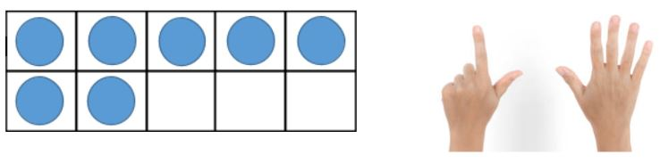
3. Can your child quickly recognise a number of objects between 1 and 10 in a ten-frame or on fingers without counting?
Children need to be able to quickly recognise numbers of objects fewer than 6 without counting them. This quick recognition is called perceptual subitising. They also need to be able to recognise numbers of objects greater than 6 by recognising smaller groups, combining them and by recognising familiar patterns (e.g. quickly recognising seven fingers by seeing five on one hand and two on the other). Developing a strong visual awareness of number will help develop your child’s number sense. Practice this by placing objects in a ten-frame (see below) and by repeated counting of fingers until children can subitise these numbers fluently. (In both cases, note how important it is for children to begin using 5 as an anchor for recognising larger numbers.)
4. Can your child count up, starting on any number between 1 and 20?
If not, practise this, ensuring that your child begins and ends on different numbers (e.g. count up from 9 to 15).
5. Can your child count down, starting on any number between 1 and 20?
If not practise this, ensuring that your child begins and ends on different numbers (e.g. count down from 18 to 11).
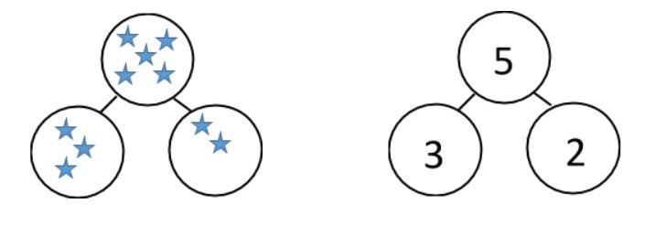
6. Can your child recognise that numbers can be partitioned?
A great way to check this is to show children a small number of objects, get them to close their eyes, cover some of the objects and then ask how many are covered. This can be further practise by exploring part-whole models with objects and then with numbers (see below).
7. Has your child begun to understand place value?
Specifically, does your child understand the significance of two digit numbers and that each digit in a two-digit number represents something different due to its position (i.e. in 16, the 1 represents 1 ten and the 6 represents 6 ones.) Practising part-whole models for two-digit numbers that partition numbers into tens and ones can be useful way to develop understanding of this concept and place value more widely:
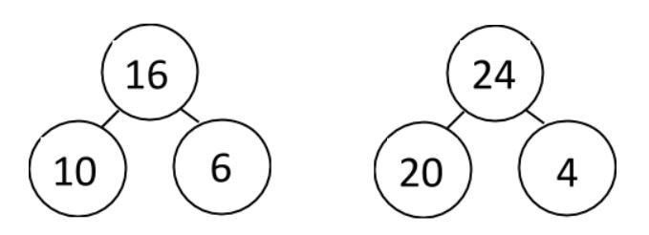
As your child starts Year 2, it will be difficult to target every area of the curriculum, so if focus can be made on the basics then this will provide the best framework for your child’s maths learning:
- Number bonds inside 10 and 20
- Relationships between numbers ( e.g. 4+6=10; 6+4=10; 10-6=4; 10-4=6)
- Multiplication and division facts for the 2, 5 and 10 x tables
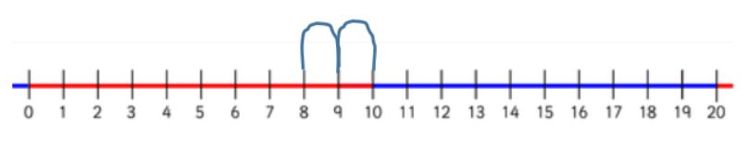
- Counting on
One of the simplest strategies that children use for addition, counting on takes time and practice to develop. For example, children may initially instead use a count all strategy: when calculating 2 + 5, your child may show two fingers and five fingers and then proceed to count them all. It’s important to note that this isn’t a ‘wrong’ strategy. However, to develop your child’s use of a ‘count on’ strategy, encourage them to recognise that addition can take place in any order. Commutativity means it is more efficient to begin counting from the larger number. This can be supported with use of a number line.

Multiplication in Year 2
Begin by helping your child to understand a basic interpretation of multiplication as repeated addition. 5 x 2 can be considered as 2 lots of 5 (or 5 + 5). Equally, 2 x 5 can be considered as 5 lots of 2 (or 2 + 2 + 2 + 2 + 2.) Develop this understanding by showing this using objects:
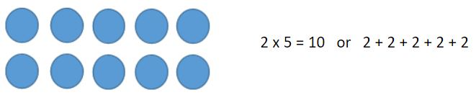
This representation of multiplication is known as an array. Arrays also serve to demonstrate that the multiplication calculations give the same answer regardless of the order of the numbers being multiplied. The array can just as easily be seen as 2 lots of 5 as 5 lots of 2..To further support your child’s multiplication, it can be useful for them to learn to count in 2s, 5s and 10s, keeping track of how many have been counted using fingers or objects.
- Division in Year 2
Alongside multiplication, children will also learn about division in Year 2. To support this, ensure that they become familiar with two interpretations of division: grouping and sharing. Grouping involves seeing a calculation such as 10 ÷ 2 as, “How many groups of 2 can be made from 10?”
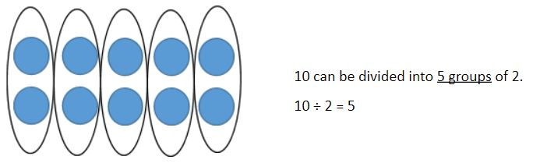
Sharing involves seeing 10 ÷ 2 as, “If I share 10 into 2 equal groups, how many are in each group?”
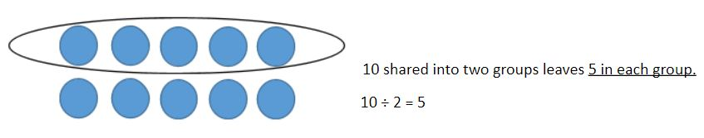
- Numbers up to 100
In Year 2, your child will be expected to be able to calculate using numbers up to – and a little beyond – 100. While you might want to get them to begin using formal written methods, resist this temptation in favour of developing their ability to work with numbers mentally.
Creating or printing a 1-100 number square or number line for children to use at home is an excellent way to support your child’s understanding of a range of mental calculations and the patterns of our number system.

