Welcome to Year 4!

Dear Parent / Carer,
Welcome back to school and a big warm welcome to Year Four, after what I hope was a lovely summer holiday. I am looking forward to a fantastic year of learning with you and your children (with them being slightly older than the last time I taught them!)
We cover a different topic every half term in Year 4 and these are our topics for the year:

Terms:
Autumn term 1: Time Zones Around the World
Autumn term 2: The Celts
Spring term 1: The Romans
Spring term 2: Our Restless Earth - Volcanoes, Earthquakes and Tsunamis
Summer term 1: Settlements
Summer term 2: The Anglo Saxons
These are some fantastic topics and should hopefully allow us to have some great school trips later on in the year.

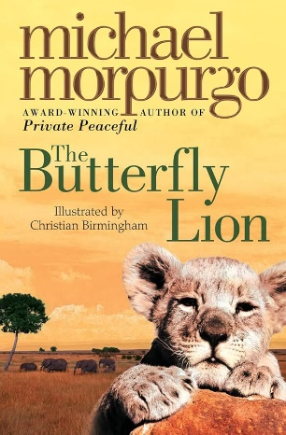
English/Maths/Science overview:
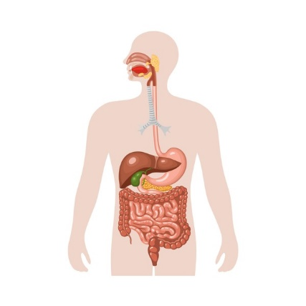
Maths this half term is going to be all about number and place value. The children will be working on their knowledge of thousands, hundreds, tens and ones in various different ways. They will also learn how to count in 6s, 7s, 9s, 25s and 1000s, looking at negative numbers, rounding and Roman Numerals. In English, we are sharing the story of ‘The Butterfly Lion’ by Michael Morpurgo. Whilst reading the book, we will learn about speech punctuation and adverbials, then will eventually write the beginning of a new chapter for the book. The focus in Science this term is ‘Animals Including Humans’. We will learn about teeth and investigate what happens when they decay. We will also learn about digestive system and food chains. This unit is a great opportunity for us to conduct some experiments.


Reading:
Everyone in class should now have taken their ‘Star Reader’ test on Accelerated Reader to determine their new reading level. The Orcas will start on books at the bottom end of their level, allowing them room to progress up to the higher end of their band by Christmas. The higher the children’s accuracy, the faster they will be able to move up their reading level band.

Our first class book is ‘Stig of the Dump’. Once we have finished that, I am looking forward to buying some new books to share with the class. If the children have any recommendations, let me know!

Information and Reminders:
- Our P.E. days are Wednesday and Thursday. Please could your child wear their P.E. kit into school on these days. As it gets colder, they are welcome to wear their fleece or cardigan.
- Reading logs and books need to be in school every day in Year 4.
- Work for home:
- Spellings will be available on Spelling Frame every Friday, to be tested on in class the following Friday. The class has been split into two spellings groups. Please find logins for Spelling Frame stuck inside the front cover of your child’s reading log.
- If your child is absent on a Friday when spellings are given out, spare copies can always be found on the whiteboard for them to take and stick in their reading logs.
- A piece of homework related to our lessons in class will be handed out on Fridays, to be returned by the following Friday.
- It is important that your child is reading every night in order to progress and/or complete Accelerated Reader quizzes in school or to move through the reading stages. We will be monitoring the children’s accuracy after each quiz.
- Times tables are an important part of Maths in Year 4. Logins for Times Table Rockstars (and Numbots) have also been stuck on the inside of your child’s reading log. There will be various challenges set on TTRS throughout the year.
- This year, updates on what the Orcas are up to will be posted straight onto the school website or Instagram page. Any messages will be sent out on the school newsletter, on a paper letter or via ParentMail.
If you have any questions or concerns, please do not hesitate to contact me.

Best wishes,

Mrs. Anna Garrod

