Year Four Maths at Acton
The national curriculum states that in Year 4 there should be a focus on becoming increasingly fluent with whole numbers and the four operations (mental and written methods), including number facts and the concept of place value.
This includes, but is not limited to, securing knowledge in:
- Place value – Reading, writing, ordering and comparing numbers to at least 1,000 and determining the value of each digit.
- Addition and subtraction – Adding or subtracting whole numbers with up to 4 digits using the column method.
- Multiplication and division – Multiplying and dividing numbers mentally up to 12 x 12. Using formal methods to calculate larger questions.
- Fractions – Adding and subtracting fractions with the same denominator and converting fractions up to 1/100 into decimals.
- Measurement – Converting between different units of metric measure; calculating the area and perimeter of rectangles and using 12/24 hour clocks.
- Geometry – analyse shapes and their properties, and confidently describe the relationships between them.
Times tables are also a big focus and by the end of year 4, pupils should have memorised their multiplication tables up to and including the 12 multiplication table and show precision and fluency in their work.
With Year 3 and the gradual transition into Key Stage 2 maths that comes with it now complete, your child may find that maths is probably becoming more of a challenge. You may start to notice frustration with some of the harder topics (even if your child has been a maths whizz so far).But don’t panic! This is a common occurrence amongst 8-year-old children, especially when it comes to maths. One of the most important things you can do as a parent at this point in your child’s mathematical development is to keep their enthusiasm going, especially in the face of any mind-boggling maths problems that may be making an appearance.

Helping at home with Year 4 Place Value:
Understanding the concept of place value underpins all maths learning really in primary and is something we recommend you help your child to be rock solid in.
What this means is knowing what the value of each digit in a number is and that by moving a digit one place to the left its value becomes 10 times larger. The same clearly applies by moving a digit to the right.
Make sure when you’re practising place value with your child you always have a place value chart to hand as in the image below. It looks simple but it just helps to bring children back to the facts rather than panicking!
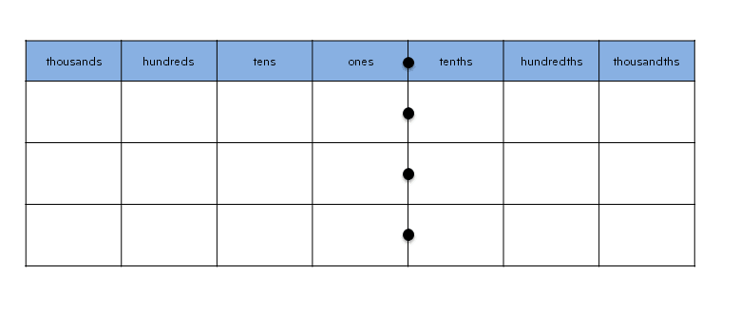
One of the best resources for this is this free downloadable place value grid which takes no time at all to make and then you can physically manipulate the numbers to show their place value.
We often play the ‘bin game’ in class to help grasp this context. We usually start with just hundreds. Your child needs to draw 3 lines and a bin. The dice needs to be rolled 4 times in total. Every time the dice is rolled, they must write that number down, either on a line or in the bin. They can have one number per line/in the bin. The aim is to make the biggest or smallest number possible.
H T O


Helping at home with Year 4 addition and subtraction in Maths
At this age, your child will notice that numbers seem to just get bigger and bigger so you need to make sure they are comfortable in dealing with them. Involving them in major purchasing decisions is a great way to get started. While you’ll always have the final say, showing your child that big numbers have a use in everyday life will help to make maths more concrete and in turn, easier to grasp.
Just make sure they add up everything on your shopping list – be it real or imaginary.
Questions you can ask to stimulate further Year 4 maths addition include:
- How much would it cost to buy all the things on their list?
- How could they make the money?
- How many hours would it take to earn the total?
In school, column addition may look like this:
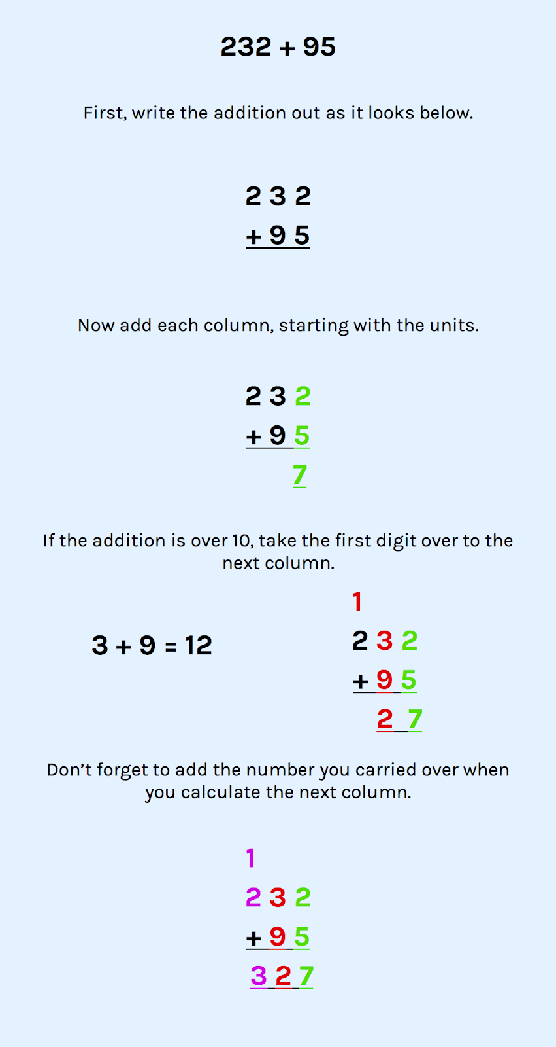

H T O

H T O

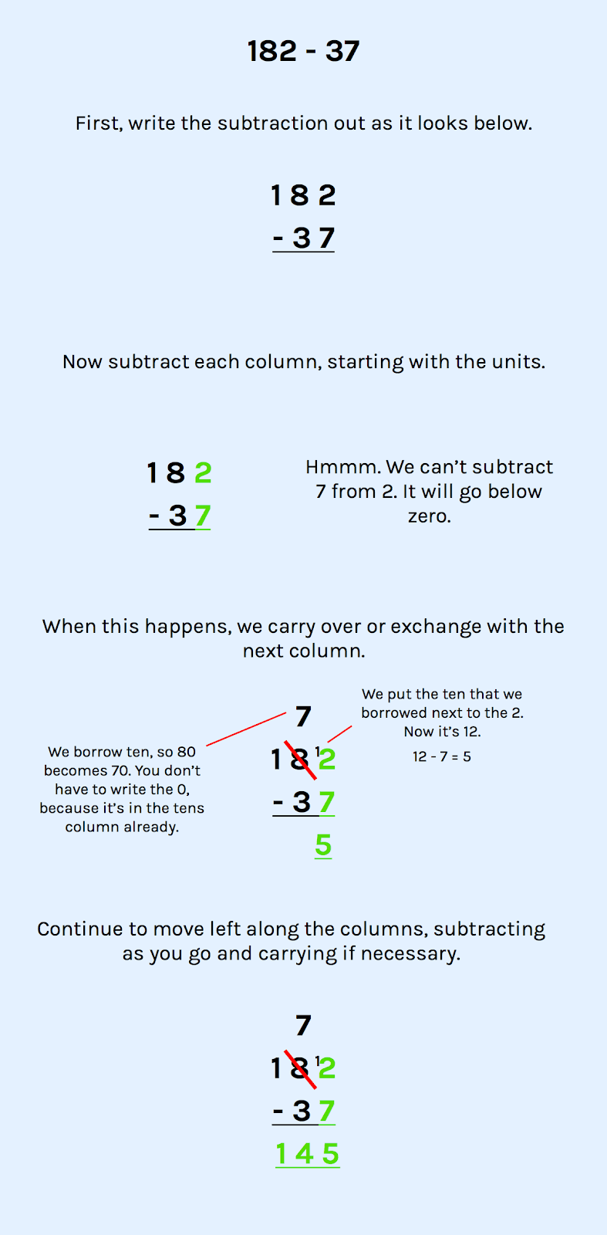

Here is an example of column subtraction:

Helping at Home with Year 4 Multiplication and Division:
You would be forgiven for thinking that teachers in lower KS2 seem to have an obsession with times tables. Year 3 and Year 4 have always been the ‘times tables years’ but the introduction of the new multiplication tables check has focused the minds of all teachers. This happens in the summer, so in Year 4, a lot of time is spent preparing for this. You might be wondering what the point is of learning times tables. The truth is, by the end of Year 4, if your child has a secure knowledge of all 12 times tables, they will be much better equipped to learn all the cognitively more challenging multiplication and division skills of upper Key Stage 2 not to mention fractions, ratio and proportion.
A times table grid is always a good place to start:
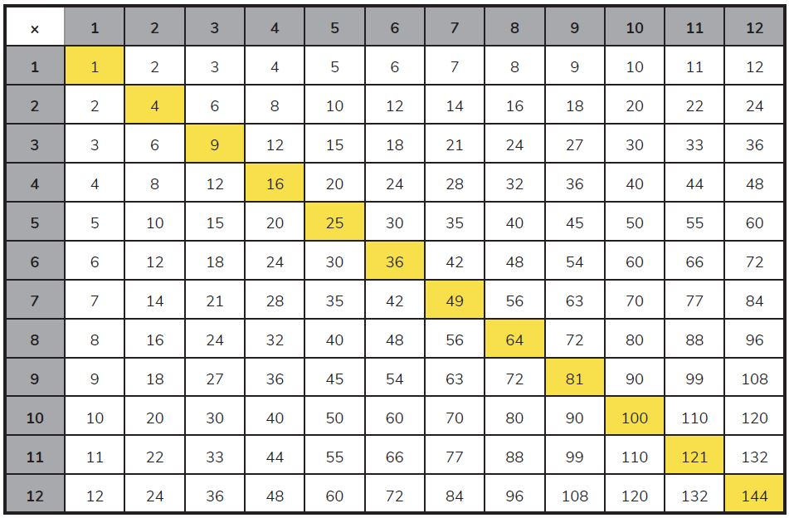

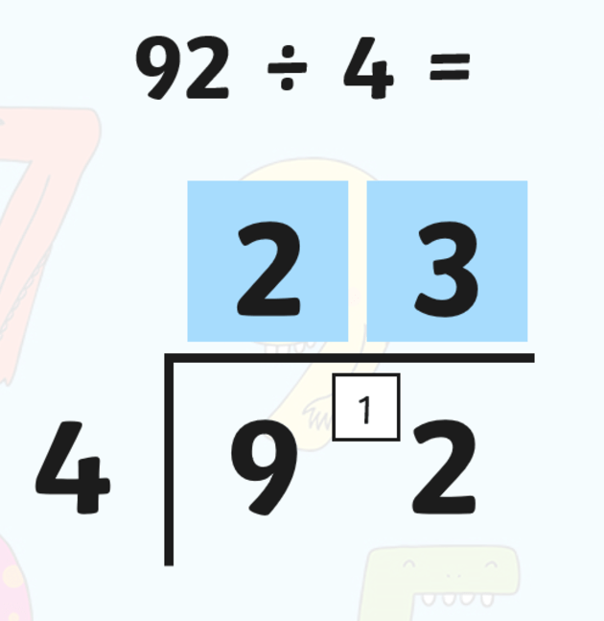
There are two formal methods that we learn in Year 4 – bus stop division and formal multiplication. They look like this:
You can fit two 4s into 9, with 1 leftover. The 2 is written above the 9 and the remainder is written in front of the 2. The 2 has now become a 12. You can divide 4s equally into 12 three times. The 3 is then written above the 2.

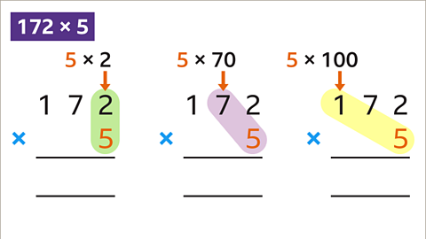
1 7 2
X 5
8 6 0
3 1
5 5
0
3 1
5 5
0
3 1
5
0
1

Start with timesing the ones column together. 5x2 = 10. The ones you can write straight in, as there won’t be anymore numbers for the ones column. The tens you write below, ready to add later.
You now repeat this process with timesing the tens and then hundreds by the 5.
To simplify 5x70, we calculate 5x7 first and then add a 0.
5x100 is 500, which you write below, ready to add.
Once you have completed the multiplication, you can add the numbers up underneath for each column.

Helping at Home with Year 4 Fractions:
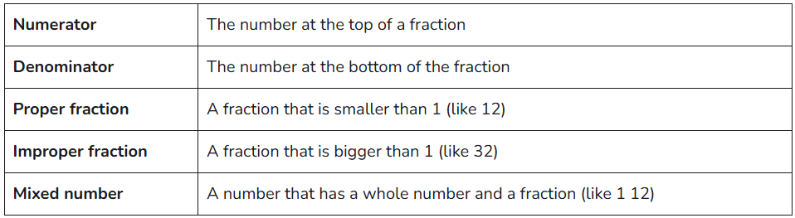

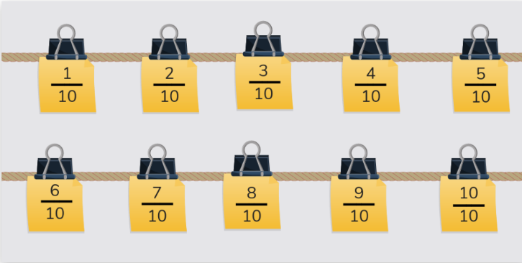
At this age, the Year 4 maths curriculum requirements focus on ordering fractions, which is simple once you know your way around a basic fraction.

Helping at Home with Year 4 Measure:
One simple thing you can do at home is to see how much your child understands about measurements and units of measurement.
To do this, investigate the length, height, weight or capacity of items that you find around the house as appropriate.
Children will spend some lessons converting units of measurement, so this is a good thing to have a go at at home too.
Helping at Home with Year 4 Geometry:
Geometry in Year 4 goes beyond being able to name shapes. Children will need to compare their properties, angles, lines of symmetry, positions on a quadrant and to be able to plot points to create a polydron.
Shapes can present a very exciting opportunity for your child to explore a whole new world of engineering and design.
If you have a child that loves to build, by channelling this in the right way you can introduce both 2D and 3D shapes to them and you’ll be amazed at how quickly they become engaged with maths!
If you have a box of single-use plastic straws in the house, why not get more out of them by using them for a fun maths construction task for your child?
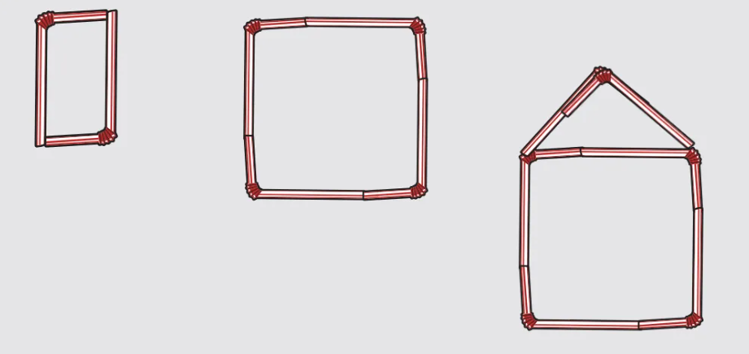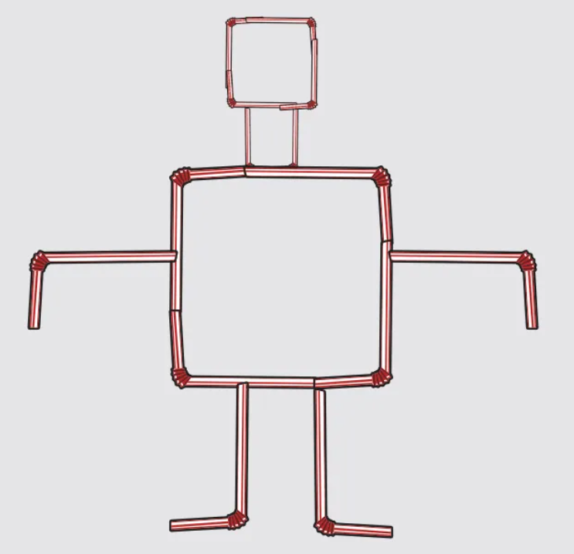
No matter what they decide to make, the key here is to talk about the shapes as you use them, rather than just drilling your child on the names and properties.

Helping at Home with Year 4 Statistics:
Data analysis might seem like a lofty prospect to an 8-year-old, but this is a great time to introduce your child to the various ways data can be presented.
Many school projects focus on collecting data in class rather than reading it, so at home you can support your child’s learning by getting into what the graphs actually mean.

Year 4 Statistics Activities: Bar charts, line graphs and pictograms
Does your child love dolphins? Research how many there are in each ocean and plot them on a bar chart.
Are they scientists at heart? Grow a plant and plot its height on a line graph.
Got a football fanatic in the family? Work out how many goals were scored last season by each team in the Premier League and create a pictogram using team colours.

Please speak to your child’s class teacher or visit: https://thirdspacelearning.com/ for further explanations and ideas

