Year Six Maths at Acton
The principal focus of mathematics teaching in Year 6 is to ensure that pupils extend their understanding of the number system and place value to include larger integers – numbers up to 10 million. This should develop the connections that pupils make between multiplication and division with fractions, decimals, percentages and ratio.
At this stage, pupils should develop their ability to solve a wider range of problems, including increasingly complex properties of numbers and arithmetic, and problems demanding efficient written and mental methods of calculation.
With this basis in arithmetic, pupils are introduced to the language of algebra as a means for solving a variety of problems.
Teaching in geometry and measures should build on and extend knowledge developed in number. Teaching should also ensure that pupils classify shapes with increasingly complex geometric properties and that they learn the mathematical vocabulary they need to describe them.
By the end of year 6, pupils should be fluent in written methods for all four operations, including long multiplication and division, and in working with fractions, decimals and percentages.
Pupils should read, spell and pronounce all their mathematical terms correctly.

Topics in the Year 6 Maths programme of study
- Number and place value
- Addition, subtraction, multiplication and division
- Fractions including decimals and percentages
- Ratio & proportion
- Algebra
- Measurement
- Geometry (properties of shapes)
- Geometry (position and direction)
- Statistics

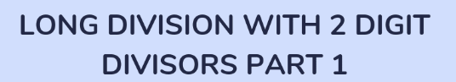
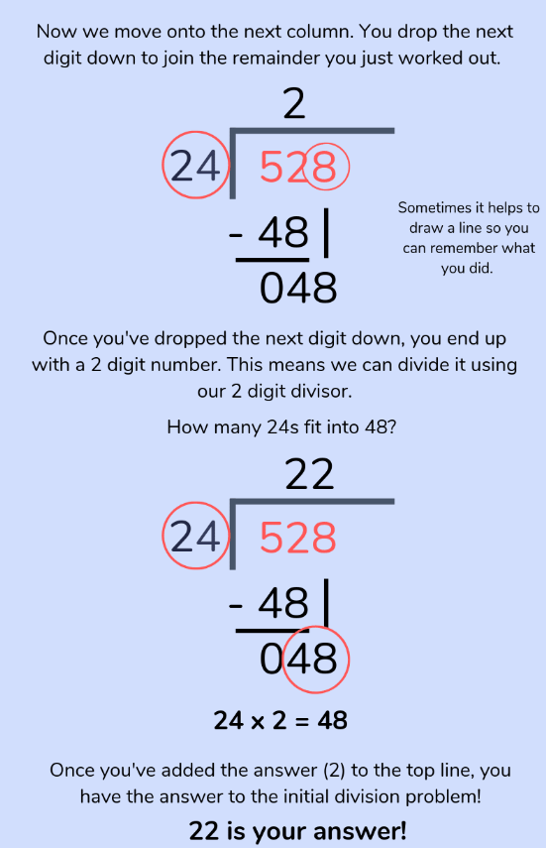
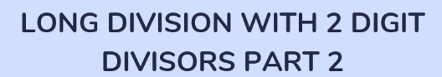
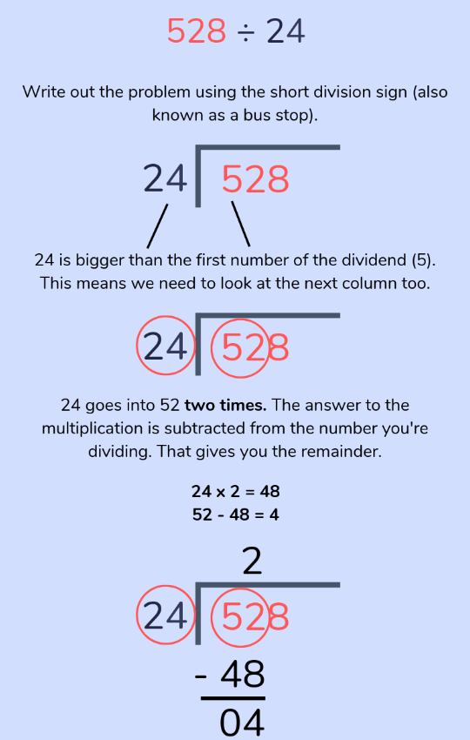
Helping at home with long division

Different division questions call for different methods of division to solve them, but here is a quick and easy guide to show which method your child should use and when:
- Chunking is best for smaller numbers and arithmetic.
- Short division is great for dividing larger numbers by one-digit numbers.
- The long division method is handy for dividing large numbers by numbers with 2 or more digits.

Helping at home with fractions including decimal and percentages

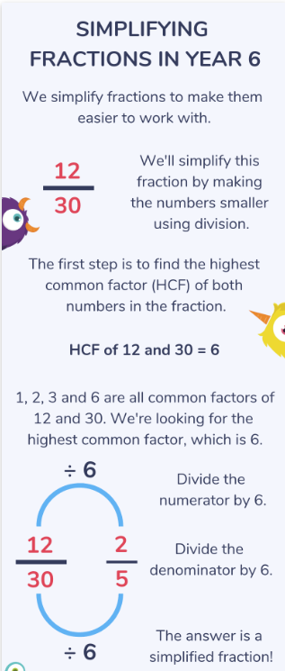
In year 6 maths lessons children will also learn subtracting fractions and how to work with mixed numbers and how to multiply fractions with different denominators. There’s a lot to cover, so just support your child to work with what they’re learning.
By the end of Year 6, your child will need to know how to convert fractions into decimals and decimals into percentages.
- Converting fractions into decimals: Divide the numerator by the denominator.
- Converting decimals into percentages: Multiply the decimal by 100. For example, 0.79 would become 79%.
- Converting percentages into decimals: Divide the percentage by 100. So, 87% would become 0.87.
- Converting percentages into fractions: Put the percentage amount over 100 (e.g. 75% = 75/100), then simplify it – in this case ¾ .

Helping at home with ratio and proportion

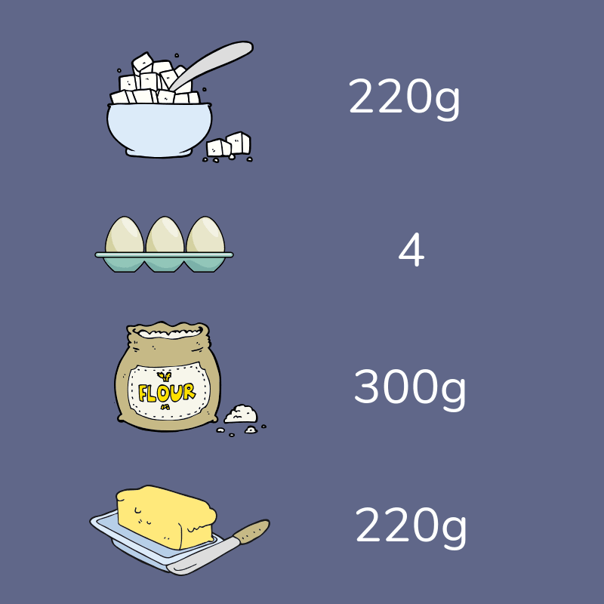
Year 6 Ratio activity: Dealing with discounts while sale shopping
When you’re out shopping practise working out sale discounts.
Work out 10% to begin with, before working your way up to multiples of 10% and 5%.
There’s really no substitute for concrete learning when it comes to these concepts – Year 6 maths becomes a lot easier when you practise it in context!

Year 6 Ratio activity: Baking recipes
Find a recipe that serves a lot of people and ask your child to think about how they can make the recipe the right size for you using division and fraction terminology (“We’ll need half/a quarter/an eighth of this recipe”).
An example of a maths question could be:
Last week you made a cake that had 8 slices. Unfortunately, this was too big and some of it had to be thrown away!
You want to make another cake this week, but you only need to use half the amount of ingredients.
Last week’s cake recipe:
- 220g butter
- 220g caster sugar
- 4 large eggs
- 300g flour
- 80g raspberry jam
Can you work out how much of each ingredient you would need to make a cake half this size?
Can you work out how much of each ingredient you would need to make a cake a quarter of this size?

Helping at home with measurement
In Year 6 children learn to convert units of measure, length, mass, volume and time from a smaller unit to a larger unit and vice versa. Also between imperial (miles) and metric units (kilometres)
As a refresher, these are the facts they’ll need to know:
10mm (millimetres) | = | 1cm (centimetre)
100cm (centimetres) | = | 1m (metre)
1000m (metres) | = | 1km (kilometre)
1000g (grams) | = | 1kg (kilogram)
1000ml (millilitres) | = | 1l (litre)
1 kilometre | = | 5/8 mile

They will also be looking at volume of cubes and cuboids, and comparing area and perimeters of shapes such as parallelograms and triangles.
There are lots of ways to build on your Year 6 child’s measurement lessons at home. Start by highlighting the weights and measurements of everyday kitchen foodstuffs just to show them what 500g looks like or 1 litre.
Measure every member of the family and work out the differences in height. Look at other items and think about what you would use to measure them. For example, Year 6 maths tests often seem to include questions about capacity of buckets and most 10 and 11 year old children really struggle with knowing how much a bucket would hold (generally about 2 or 4 litres).

Helping at home with geometry (Properties of Shape; Position and Direction)
The topic of geometry in Year 6 maths is split into two subtopics: shape and position and direction. The latter is mostly about plotting points on a quadrant so it helps to make sure your child knows the difference between the x-axis (across) and the y-axis (up and down).
Shape can prove a little trickier. Children are expected to compare and classify geometric shapes based on their properties and sizes and find unknown angles in any triangles, quadrilaterals, and regular polygons. They also use nets to build 3-D shapes.
They will do lots of angles work, starting to use a protractor, and working out, where angles meet and what missing angles amount to. They’ll also start to understand the parts of a circle knowing that the diameter is twice the radius.

Year 6 Geometry activity: Protractor practice
Protractors are often a mystery to primary school age children, so you can clear things up by using them often around the house.
A quick and easy way to handle a protractor is:
- 1: Use a ruler to draw a few different sized angles on a sheet of paper.
- 2: Challenge your child to measure as many as possible in a minute.
- 3. Next, switch roles!
- 4: It’s your turn to measure as many angles as possible, in a different colour pen, for one minute.
- 5: Once all the angles are measured, go back and check for accuracy.
- 6: Whoever got the most angles right wins the game (and perhaps a small reward!).

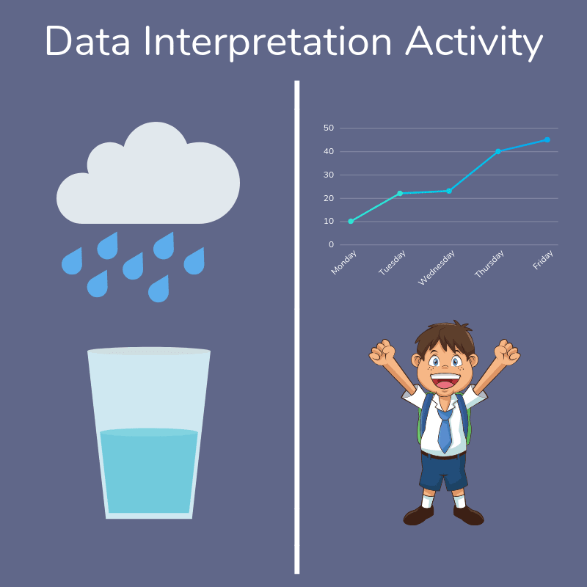
Helping at home with statistics
In Year 6 statistics, children use pie charts and line graphs to solve problems, as well as revising other forms of data representations from pictograms and line graphs to frequency tables. They will also be looking at the mean as an average.
Part of becoming confident in Year 6 maths is being comfortable with a range of mathematical information.
If your child is getting mixed up interpreting data it’s a good idea to go back to basics and have a go at conducting a few surveys around the house before setting out the results in tables and graphs.
Year 6 Statistics Activity: Charting the Weather
Here’s a great activity to do in the rainy months (which shouldn’t be hard to come across in England!) to help with data interpretation through using a real-life example that even helps boost our science understanding.
Dot Your Data: A fun Year 6 maths activity
- Step 1: Pop a glass outside to collect water.
- Step 2: Measure the amount that falls each day.
- Step 3: Record the results in a table.
- Step 4: After one week, plot the results on a line graph.

Year 6 Maths…SATs, SATs, SATs…
When it comes to Year 6 maths, mention of the SATs test is never far away.
For many children this age, the transition into a formal exam year can be stressful, so now is the time to practise working through challenges with a cool head.
As a parent, you might feel under pressure too. Mathematics for children can be a minefield, and when everyone is talking about test scores and booster groups, it can be hard not compare your child’s progress against that of other children.
Every child is different, so your best bet is to focus on your own child’s needs instead of worrying about everyone else (no matter how much they go on about what’s right and wrong for the exams!).
The KS2 SATs in Maths consists of 3 papers: 1 Arithmetic Paper and 2 Reasoning Papers. The latter tests 10 and 11 year olds ability to reason and problem solve using the maths knowledge and skills they have learnt at primary school.
How to answer SATs reasoning questions
Chances are your child will be practising test questions at school almost daily.
However, at school, the focus will be on working these questions out independently, which leaves a lot of room for misinterpretation.
Most teachers will revisit the harder questions, but it’s a good idea to practise at home so you can identify which questions are causing headaches.
Once you know which ones are problematic, you can work on a strategy to solve them in plenty of time for the exams.
This method isn’t foolproof as the examiners are always thinking up new ways to trip children up but when faced with a problem that seems insoluble it’s worth having a strategy to fall back on. This is what we recommend.
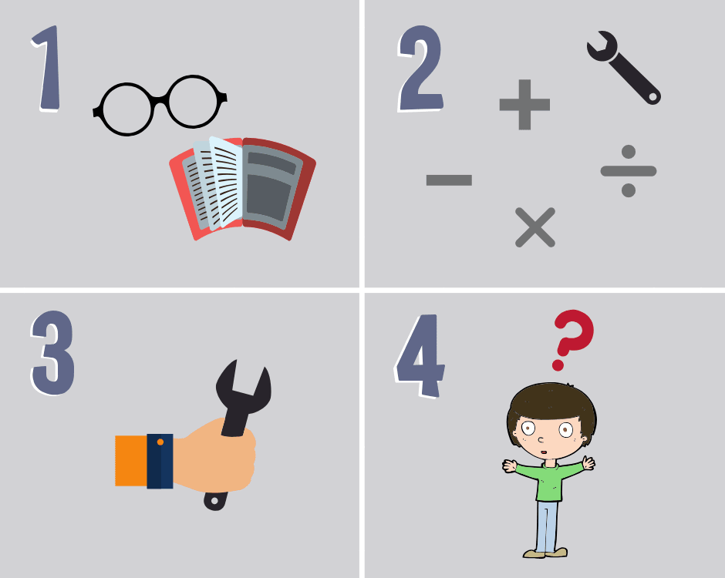
1. Read the whole question
- Find words that you know.
- Find words that you don’t know. Can you work what they mean from what’s around them?
2. Choose which tools to use
- Which operations make sense here? Addition, subtraction, multiplication or division?
3. Try out your tools
- Present work neatly so it’s easier to keep track later.
4. Check that the answer makes sense
- If it does, do a quick check of your work.
- If it doesn’t, work through the steps again.

Simple maths problems to work through with your 10 year old
Bill had three apples and ate two. How many did he have left?
Connor had £5. He spent £3 on lunch. How much money does he have left?
Rachel had 4 dogs. She bought 1 cat. How many pets does she have now?
If you manage to talk about the different ways you could approach the problem this will be very beneficial as dialogue around the process really helps understanding in maths.
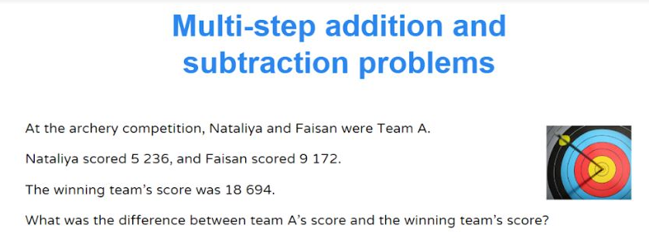

More complex multi step maths problems for your 11 year old
1. Potatoes cost £1.50 per kg and carrots £1.80 per kg. Jack buys 1½kg of potatoes and ½kg of carrots. How much change does he get from £5?Answer: £1.85
2. Wishy Washes car wash process 92 cars per day. they make £15 per car. How much money will they have made in 4 days.
Answer: £5,520
3. An aeroplane is flying from Birmingham to New York. The distance between these two cities is 5,400km. On the journey the pilot announces “We are 40% of the way through the flight.” How far has the aeroplane travelled?
Answer: 2,160 km

