Maths in Year 3
The principal focus of mathematics for Year 3 is to ensure that pupils become increasingly fluent with whole numbers and the four operations. This should ensure that pupils develop efficient written and mental methods and perform calculations accurately with increasingly large whole numbers.
Pupils should develop their ability to solve a range of problems, including with simple fractions and decimal place value. Pupils should draw with increasing accuracy and develop mathematical reasoning so they can analyse shapes and their properties, and confidently describe the relationships between them. Children at this stage should also be using measuring instruments with accuracy and make connections between measure and number.
The Year 3 maths curriculum is then broken down into the main topics that pupils learn across their years at school.
- Number & place value
- Addition & subtraction
- Multiplication & division
- Fractions
- Measurement
- Geometry
- Statistics
Times tables are also a big focus in Year 3; by the end of the year, all children should be secure in their 2s, 5s and 10s, and most children should be in the process of securing 3s, 4s and 8s.

Number and Place Value
In Year 3, children become more confident with larger numbers, mainly 3-digit but sometimes 4-digit also. At Acton, children refer to the value of numbers as hundreds, tens and ones e.g 372 has 3 hundreds, 7 tens and 2 ones. You can support your child asking them to point out the value of different digits and/or asking them to order numbers.
Concrete manipulatives can support learning of place value. At Acton, we use:

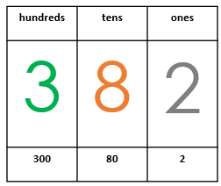
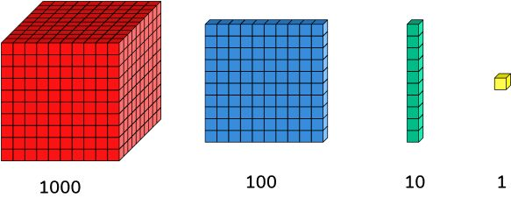
Dienes Place value charts

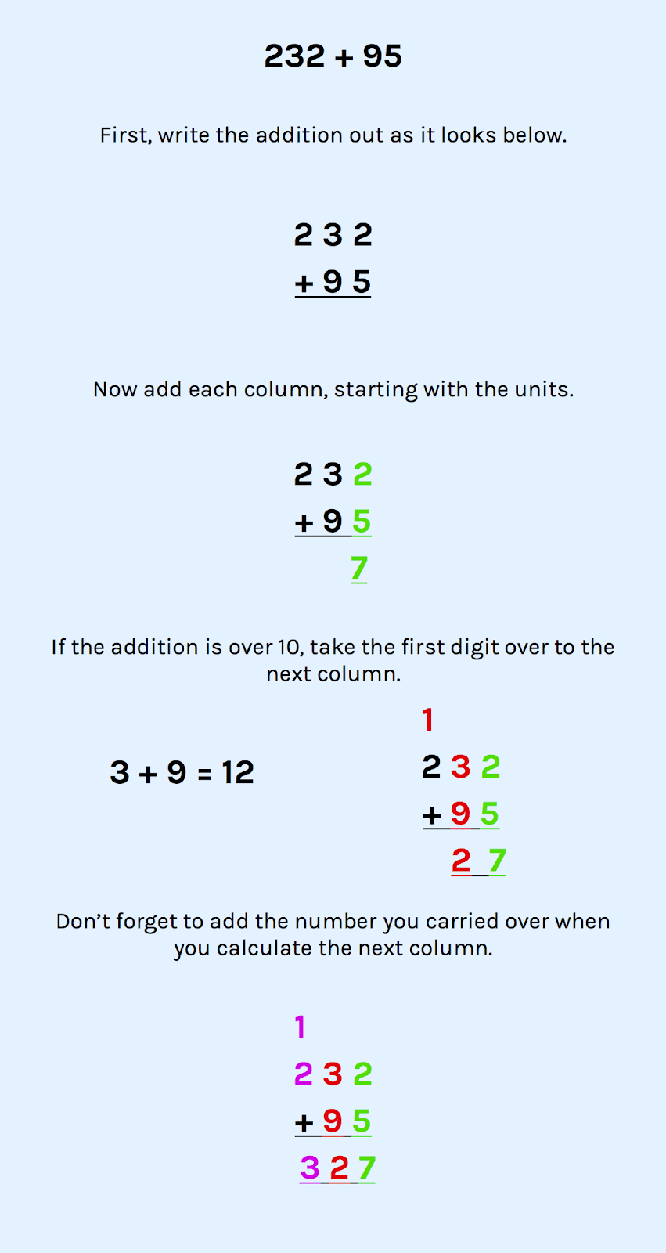
Addition and Subtraction
In Year 3, children start learning lots of different strategies for addition and subtraction including column method with up to three digit numbers. They also need to understand how to answer missing number problems where the ‘answer’ is not always after the equals sign. eg 87 + ? = 103.

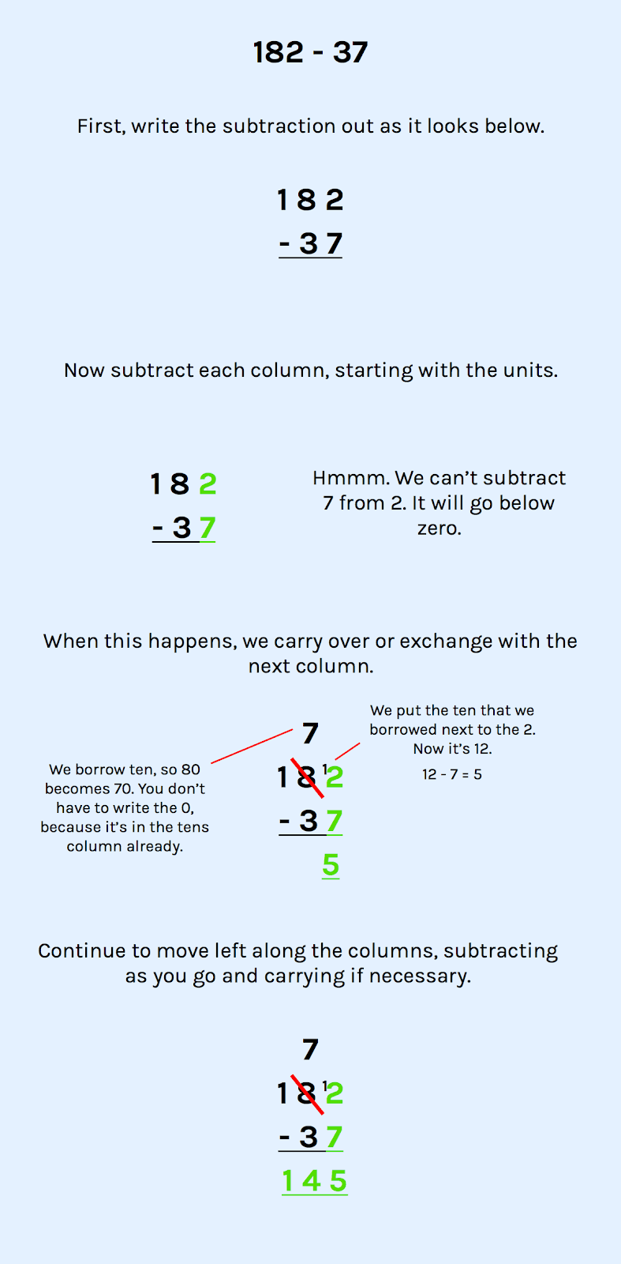

Multiplication and Division
Times tables are the foundations of many mathematical concepts; children who have embedded their times table knowledge will find concepts such as fractions, area and short division much easier to grasp. By the end of Year 3, all children should be secure in their 2s, 5s and 10s, and most children should be in the process of securing 3s, 4s and 8s. Talking to your child about their times tables and making games out of them at home can be a huge help. It’s important to remember the inverse operations too; in this case, division is the ‘inverse’ or opposite of multiplication and this concept can be a difficult one to grasp. For example, every time you practise 5 x 3 = 15, make sure to recite the other three variations including the inverse:
If we know 5 x 3 = 15, we also know 3 x 5 = 15, 15 ÷ 3 = 5 and 15 ÷ 5 = 3.
This way children can internalise their division facts as well as their multiplication facts.
Fractions

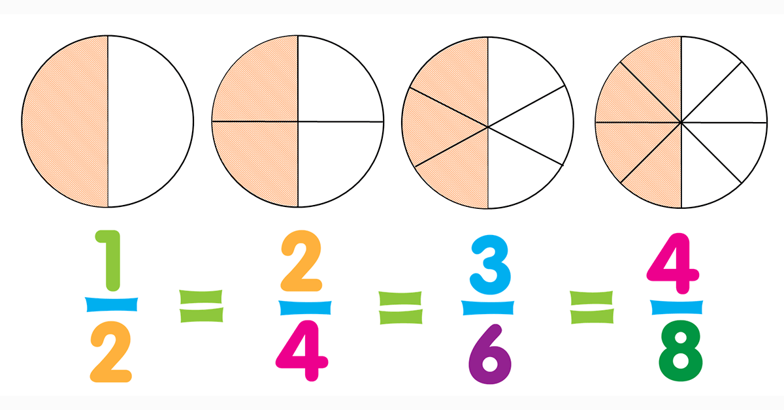
In Year 3 fractions move beyond concrete objects into the abstract concept of what a tenth or a half means, i.e dividing an object into equal parts and dividing by the number of those parts.

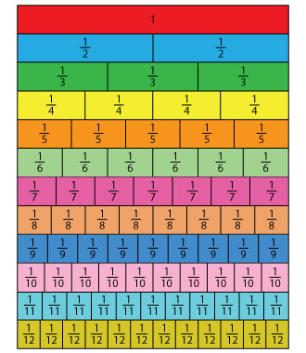
Children will also start to compare and order fractions and understand the concept of unit fractions (1/4, 1/2 , 1/15 etc) and equivalent fractions.

Children will use some visual representations to support their fractions learning, such as a fraction wall.

Measurement
Our usual understanding of measurement as measuring and comparing of lengths, mass and volume is key for Year 3 children. One way to introduce and then cement the concept of measuring accurately is to get your child measuring anything and everything with a ruler or a tape measure.
Measurement also includes lots of topics you might not necessarily imagine would fit in there such as telling the time (analogue and digital), amounts of money and number of days in a month, year and leap year. Asking your child to tell you the time, how many minutes are left until the next hour etc. is a fantastic way to support their learning. Likewise, asking them to help with paying using coins and notes, and calculating change will also help them in this unit.

Geometry
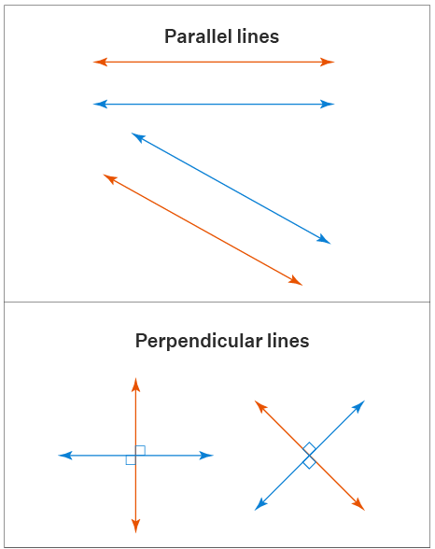
In Year 3, geometry is focused around learning 2-D shapes together with 3-D shapes. This includes shape properties, nets, angles, and parallel (lines that will never meet) and perpendicular (lines that cross to form a right angle) lines.
It is important to note that use of protractors is not a focus in Year 3; at this stage, the children are learning to identify right angles, acute angles (smaller than right angles) and obtuse angles (bigger than right angles) by sight.
Conversations around shape can be initiated using everyday items around the house or indeed outside of the house. For example, asking your child what shape their cereal box is and asking them how many faces it has.
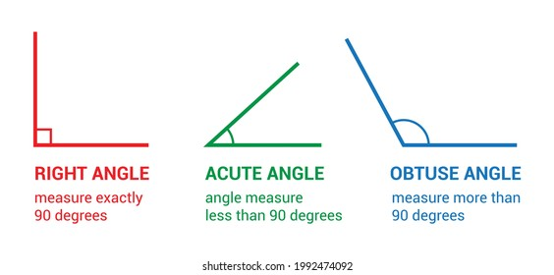

Statistics
Pictograms and bar charts follow children throughout their school career from Year 2 onwards. The statistics unit is not limited to maths lessons and is explored across the curriculum, including Computing, Science and Geography. In Year 3, pupils will see the many different ways that data can be presented and translated from something like a tally chart into a bar chart. Children will learn how to read a variety of charts and pictograms and answer questions related to the data.



