**Welcome to Year 2 Panda Class!**

Dear Parent/ Carer,

Welcome back to school, and a big welcome to Year Two! I can’t wait to start a fantastic new year of learning with your children learning a variety of new and exciting topics. I have tried to include all the information you might need in this introductory letter. However, if you still have any questions or concerns, then please do ask at the gate during morning drop off or afternoon pick up, or by calling the school office where I will get back to you at the earliest possible convenience.

During Year 2, we cover six different topics- one for each half term. These are:

Autumn 1: Felixstowe   
Autumn 2: Bonfire Night  
Spring 1: Victorians   
Spring 2: Great Fire of London   
Summer 1: Explorers   
Summer 2: Kenya

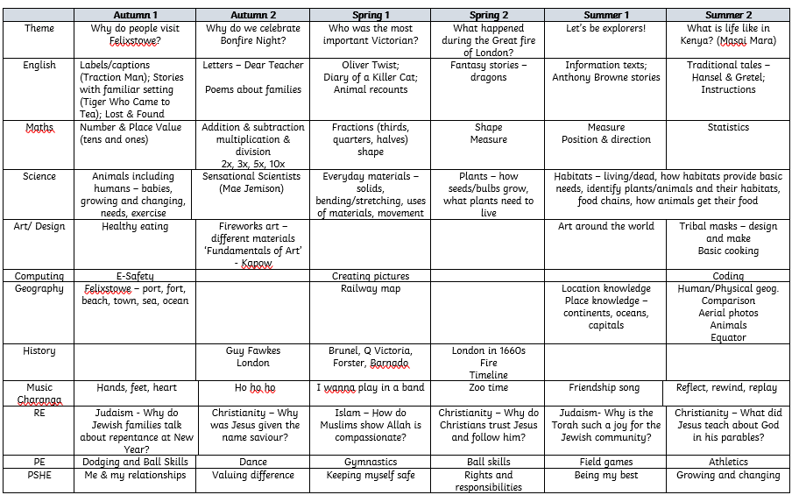Here is an overview of our plan for the year:

**Information and Reminders:**

* Our P.E. days are Wednesday and Friday. Please make sure children come to school in P.E. kit on these days.
* Each day, your child will need to bring their named water bottle, reading book/log and lunch box (if needed).
* Please ensure that during the colder weather children are wearing appropriate school uniform/ P.E. kit and that they bring a coat.
* Please try to read with your child every day. We will only change your child’s reading book when the reading log has been signed by an adult at home or at school.
* Spellings will be tested on a Friday morning. Spellings will be stuck into your child’s reading log on a Friday ready to practise over the next week. The spellings will include the sound we are focusing on in Monster Phonics that week. There are 6 spellings to learn with an optional extra 4 if you would like an extra challenge.
* Numbots is part of our Maths learning and can be accessed at home. The username and password can be found on the inside front cover of the reading log.

Best wishes,

Miss Daisy Underwood