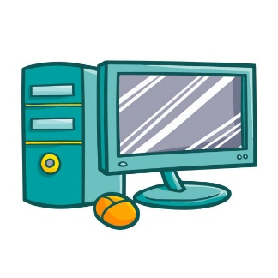Computing Curriculum Map 2024-25

|  |  |  |  |  |  |  |
| --- | --- | --- | --- | --- | --- | --- |
|  | Autumn 1 | Autumn 2 | Spring 1 | Spring 2 | Summer 1 | Summer 2 |
| Year 1 | Logging On/Tech Outside of School | E-Safety | Grouping  /Sorting | Pictograms | Maze Explorers | Coding |
| Year 2 | E-Safety | Coding | Spreadsheets | Creating Pictures | Effective Searching | Creating music |
| Year 3 | E-Safety | Presenting: PowerPoints |  | Graphing | Coding | Emails |
| Year 4 | E-Safety (using Y2 lessons) | Making Music | Effective Searching | Coding |  | Animation |
| Year 5 | Game Makers |  | Coding |  | E-Safety |  |
| Year 6 | E-Safety | Coding | Mindfulness | Quizzing | E-Safety | Text Adventures |